Appointment Booking System

**Project Submitted in Partial Fulfillment of the Requirements for the Degree of**

**Bachelor of Technology in the field of Computer Science & Technology**

### Submitted by

### **Roll No.: 123231110212**

### Under the Supervision

### Of

### **………………..**

**Department of Computer Science & Technology**

**JIS College of Engineering**

**Block-A, Phase-III, Kalyani, Nadia, Pin-741235**

**West Bengal, India**

**Jan, 2024**

**JIS College of Engineering**

**Block-A, Phase-III, Kalyani, Nadia, Pin-741235**

**Phone: +913325822137, Telefax: +913325822138**

**Website:** [**www.jiscollege.ac.in**](http://www.jiscollege.ac.in)**, Email: info@jiscollege.ac.in**

# CERTIFICATE

# This is to certify that Kishanjee Kumar(123231110212) .Has completed his/her project entitle Appointment Booking System , under the guidance of ………………. in partial fulfillment of the requirements for the award of the Bachelor of Technology in Computer Science & Technology from JIS college of Engineering (An Autonomous Institute)is an authentic record of their own work carried out during the academic year 2023-24 and to the best of our knowledge, this work has not been submitted elsewhere as part of the process of obtaining a degree, diploma, fellowship or any other similar title.

--------------------------------

Signature of the Supervisor

**Place: ……………………**

**Date: ……………………**

# ACKNOWLEDGMENTS

The analysis of the project work wishes to express our gratitude to **………………** for allowing the degree attitude and providing effective guidance in development of this project work. His/Her conscription of the topic and all the helpful hints, he provided, contributed greatly to successful development of this work, without being pedagogic and overbearing influence. We also express our sincere gratitude to ……………….., Head of the Department of Computer Science & Technology of JIS College of Engineering and all the respected faculty members of Department of CST for giving the scope of successfully carrying out the project work. Finally, we take this opportunity to thank to **Prof. (Dr.) Partha Sarkar**, Principal of JIS College of Engineering for giving us the scope of carrying out the project work.

**Date: …………………………**

**Kishanjee Kumar**

**B.TECH in Computer Science & Technology**

**2 nd Year/3 rd Semester**

**Univ Roll—123231110212**

# ABSTRACT

The project **Appointment Booking System** includes registration of patients, storing their details into the system. The software has the facility to give a unique id for every patient and stores the details of every patient.

The **Appointment Booking System** can be entered using a username and password. It is accessible either by an administrator .Only they can add data into the database. The data can be retrieved easily. The interface is very user- friendly. The data are well protected for personal use and make the data processing very fast.

The **Appointment Booking System** presented in this abstract addresses the pressing need for efficient resource management in healthcare settings. By leveraging data analytics and automation, the ABS aims to enhance patient care, optimize resource utilization, reduce operational costs, and ultimately contribute to the overall improvement of healthcare services.

(iv)

# Contents

|  |  |
| --- | --- |
| **Candidate’s Certificate** | **ii** |
| **Acknowledgments** | **iii** |
| **Abstract** | **iv** |
| **1 Introduction** | **1** |
| 1.1 Overview………………………………………………………………………………… | 1 |
| **2 Background**  2.1 Problem Statement ………………………………………………...............……….…... | **2**  2 |
| 2.2 why did we choose the project? .……………………………...…...….……….……….. | 2 |
| 2.3 What is our Objective? ……………………………………….………………….…….. | 3 |
| **3 Implementation of an Project** | **4** |
| 3.1 Application ……………………………………………………………………………... | 4 |
| 3.2 Module ……………………………………………………………………………..…… | 5 |
| 3.3 Which technologies did we employ to create our platform? …….…….…………..…… | 7 |
| 3.4 Some Snapshots of User Interface (Frontend)……………….….…………..…………… | 8 |
| 3.5 Some Snapshots of Database Interface ……………….….………………..…..………… | 12 |
| **4 Conclusion and Future Work** | **14** |
| 4.1 Conclusion .………………………………………………………….………………...... | 14 |
| 4.2 Future Work………………………………………………………….………………….. | 14 |
| **References**  (v) | **15** |

# Chapter 1 : Introduction

## 1.1 Overview

The project **Appointment Booking System** includes registration of patients, storing their details into the system. The software has the facility to give a unique id for every patient and stores the details of every patient.

The **Appointment Booking System** can be entered using a username and password. It is accessible either by an administrator .Only they can add data into the database. The data can be retrieved easily. The interface is very user-friendly. The data are well protected for personal use and make the data processing very fast.

In the dynamic landscape of the healthcare industry, efficient resource management is pivotal to providing exceptional patient care while optimizing operational processes. Our ABS is a state-of-the-art solution designed to revolutionize how healthcare organizations allocate, monitor, and optimize their resources.

In an era where every minute counts and resources are limited, our ABS offers a comprehensive and integrated platform that empowers healthcare administrators, clinicians, and support staff to make well-informed decisions. By seamlessly integrating data, technology, and human expertise, our system streamlines resource allocation, minimizes wastage, and maximizes the utilization of personnel, equipment, and facilities.

# Chapter 2 : Background

## 2.1 Problem Statement:

Many patients experience challenges when seeking appointments and treatment from doctors, facing issues such as long waiting times, difficulty in scheduling appointments, lack of transparency in treatment plans, and inadequate communication .The current process is often cumbersome, requiring multiple phone calls or online forms, leading to long wait times and potential miscommunication. Additionally, patients may struggle to access accurate information about the doctor's availability, specialization, and treatment procedures, leading to frustration and delays in receiving necessary medical care. There is a need for a more efficient and user-friendly system that simplifies the appointment scheduling process, provides transparent information about doctors and their services, and enhances the overall patient experience during their interactions with healthcare providers.

This problem statement aims to address the patient-facing aspects of the healthcare management system. Seeking to improve the overall experience and accessibility for individuals seeking medical care.

## 2.2 Why did we choose the project?

The Appointment Booking System project is chosen to address the critical need for efficient utilization of healthcare resources. This system aims to optimize the seeking of online appointments, Introduction of doctors on online platform, ensuring timely and effective patient care. By streamlining resource allocation, the project seeks to enhance healthcare delivery, reduce waiting times, improve patient outcomes, and ultimately contribute to the overall improvement of the healthcare system's effectiveness and efficiency.

## 2.3 What is our Objective?

The primary objective of the Healthcare Resources Management System (ABS) project is to create a comprehensive, user-friendly, and technologically advanced platform that enhances the patient and doctors experience for administration of online healthcare management . The aim is to provide a robust digital environment that fosters efficient healthcare dissemination, interactive engagement, and seamless administration of healthcare resources.

# Chapter 3 : Implementation of the Project

**3.1 APPLICATION**

The Healthcare resource management websites play a crucial role in optimizing various aspects of healthcare operations, administration, and patient care. These websites offer tools and features that help healthcare facilities and professionals manage their resources efficiently, improve patient outcomes, and streamline their operations. Here are some key applications of healthcare resource management websites:

#### 3.1.1 Patient Appointment Booking and Management:

Healthcare resource management websites often include features for patients to book appointments online. This reduces phone-based appointment booking and provides patients with the convenience of scheduling appointments at their preferred times. Additionally, healthcare providers can efficiently manage Appointment calendars and reduce no-shows through automated reminders.

#### 3.1.2 Resource Allocation and Equipment Management:

Effective allocation of medical equipment, hospital beds, and other resources is critical for patient care. These websites allow healthcare facilities to track the availability and usage of resources, reducing delays and improving overall operational efficiency.

#### 3.1.3 Quality Improvement and Reporting:

These websites often include reporting and analytics tools that allow healthcare administrators to monitor key performance indicators (KPIs), analyze trends, and identify areas for quality improvement.

#### 3.1.4 Patient Engagement and Communication:

Some healthcare resource management platforms offer patient engagement features such as secure messaging, appointment reminders, and educational resources to enhance patient-provider communication and engagement.

#### 3.1.5 Research and Data Collection:

Healthcare organizations involved in research studies can use these platforms to manage participant recruitment, data collection, and study coordination.

In summary, healthcare resource management websites are versatile tools that help healthcare facilities optimize their operations, enhance patient care, and ensure efficient resource allocation. These platforms contribute to better patient outcomes, improved workflow management, and increased overall operational effectiveness in healthcare settings.

#### 3.2 MODULE

The project Appointment Booking System is a web application for the hospital which manages doctors and patients.

The entire project mainly consists of 3 modules, These are :-

#### 3.2.1 Admin/ Management module :-

* **Dashboard:** - In this section, admin can view the Patients, Doctors, Appointments and New queries.
* **Doctors :-** In this section, admin can add doctor’s specialization and mange doctors (Add/Update).
* **Users :-** In this section, admin can view users detail (who take online appointment) and also have right to delete irrelevant user.
* **Patients :-** In this section, ,admin can view patient’s details.
* **Appointment History :-** In this section, admin can view appointment history.
* **Contact us Queries :-** In this section, admin can view queries which are send by users.
* **Doctor Session Logs :-** In this section, admin can see login and logout time of doctor.
* **User Session Logs :-** In this section, admin can see login and logout time of user.
* **Reports :-** In this section, admin can view reports of patients in particular periods.
* **Patient Search :-** In this section, admin can search patient with the help of patient name and mobile number

.

**Note:-**Admin can also change his/her own password.

**3.2.2 Patient module :-**

* **Dashboard: -** In this section, patients can view the his/her profile, Appointments and Book Appointment.
* **Book Appointment :-** In this section, Patient can book his/her appointment.
* **Appointment History:-** In this section, Patients can see his/her own appointment history.
* **Medical History:-** In this section, Patients can see his/her own appointment history.

**Note:-**User can update his/her profile, change the password and recover the password.

**3.2.3 Doctor module :-**

* **Dashboard:** - In this section, doctor can view his/her own profile and online appointments.
* **Appointment History:-** In this section, Doctor can see patient’s appointment history.
* **Patients**:- In this section, doctor can manage patients (Add/Update).
* **Search** :- In this section, doctor can search patient with the help of patient name and mobile number.

**Note:-**Doctor can also update his profile, change the password and recover the password.

**3.3 Which technologies did we employ to create our platform?**

#### 3.3.1 For Frontend:

1. **HTML 5: -** HTML (Hyper Text Markup Language) is a markup language that is used to structure a web page and its content.
2. **CSS 3: -** CSS stands for Cascading Style Sheets. It is a style sheet language used for describing the presentation of a document written in a markup language such as HTML. CSS is used to define styles for our web pages, including the design, layout and variations in display for different devices and screen sizes
3. **JavaScript: -** JavaScript (JS) is the most popular lightweight, interpreted compiled programming language. It can be used for both Client-side as well as Server-side developments. JavaScript also known as a scripting language for web pages. JavaScript allows us to implement complex features on our website.

#### For Backend:

**i) Core PHP: -** PHP (short for Hypertext Preprocessor) is the most widely used open source and general-purpose server-side scripting language used mainly in web development to create dynamic websites and applications.

#### For Database: -

**i) MySQL: -** MySQL is a popular open-source database management system widely used for storing and organizing data. It is known for its fast performance, reliability, and ease of use. MySQL is ideal for both small and large applications.

#### For Server: -

**i) Localhost: -** It refers to the default hostname used to access the network services running on the same device you're using. It's often represented by the IP address 127.0.0.1 and is used to access web servers, databases, and other services hosted locally on your computer.

* 1. **Some Snapshots of User Interface (Frontend)**

#### Home Page:

**Figure: 1**

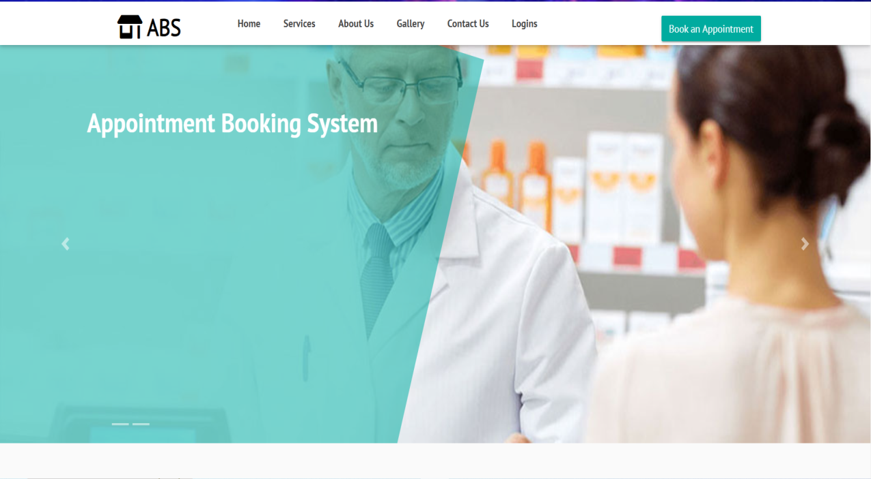

#### Login Page :

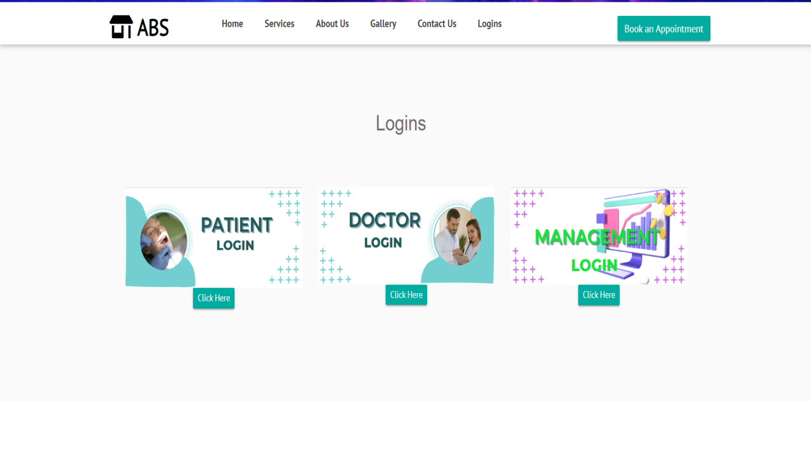

**Figure: 2**

#### Patient Login Page :

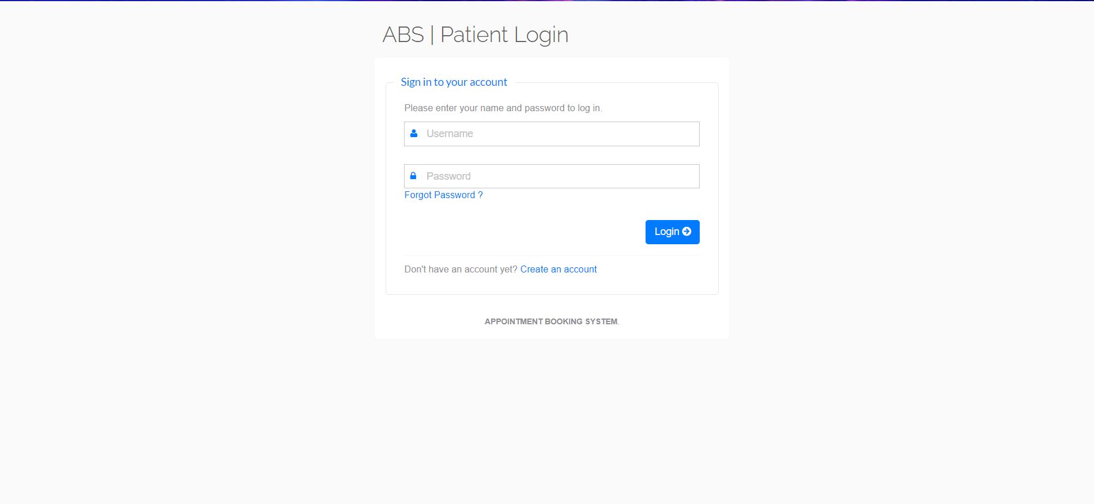

**Figure: 3**

#### Patient's Dashboard :

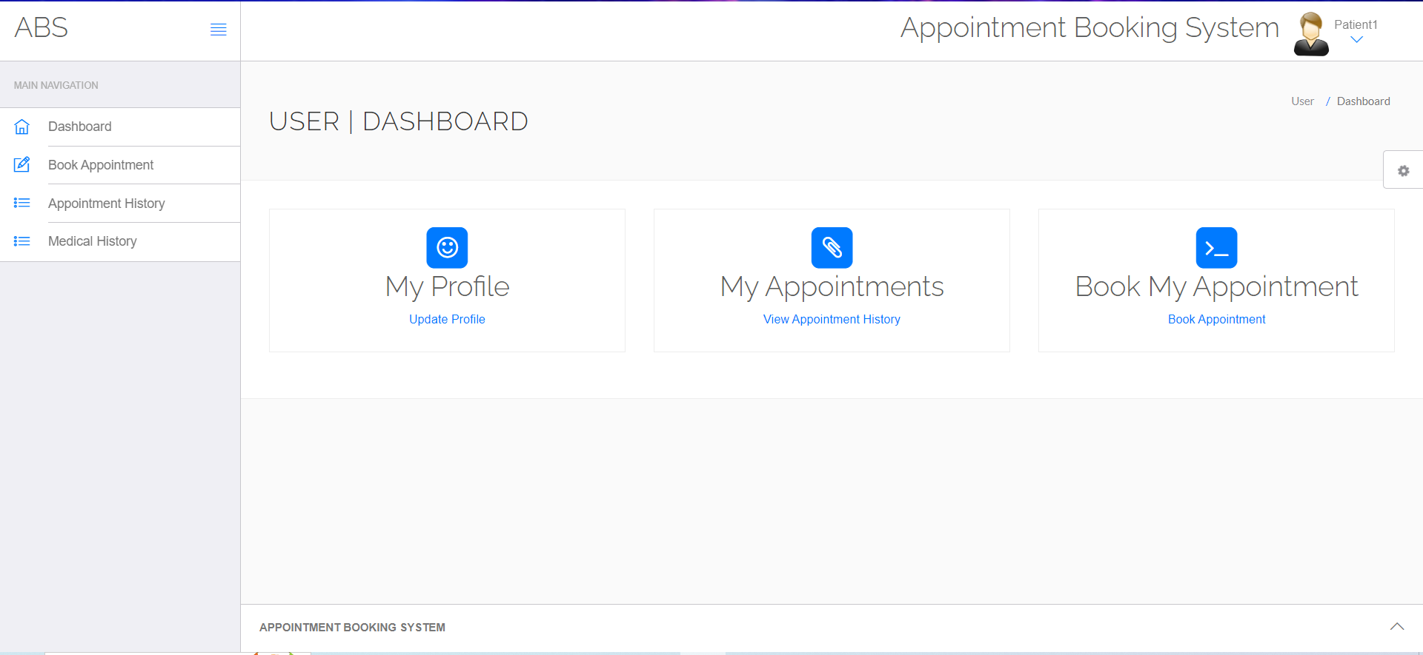

**Figure: 4**

#### Doctor’s Login :

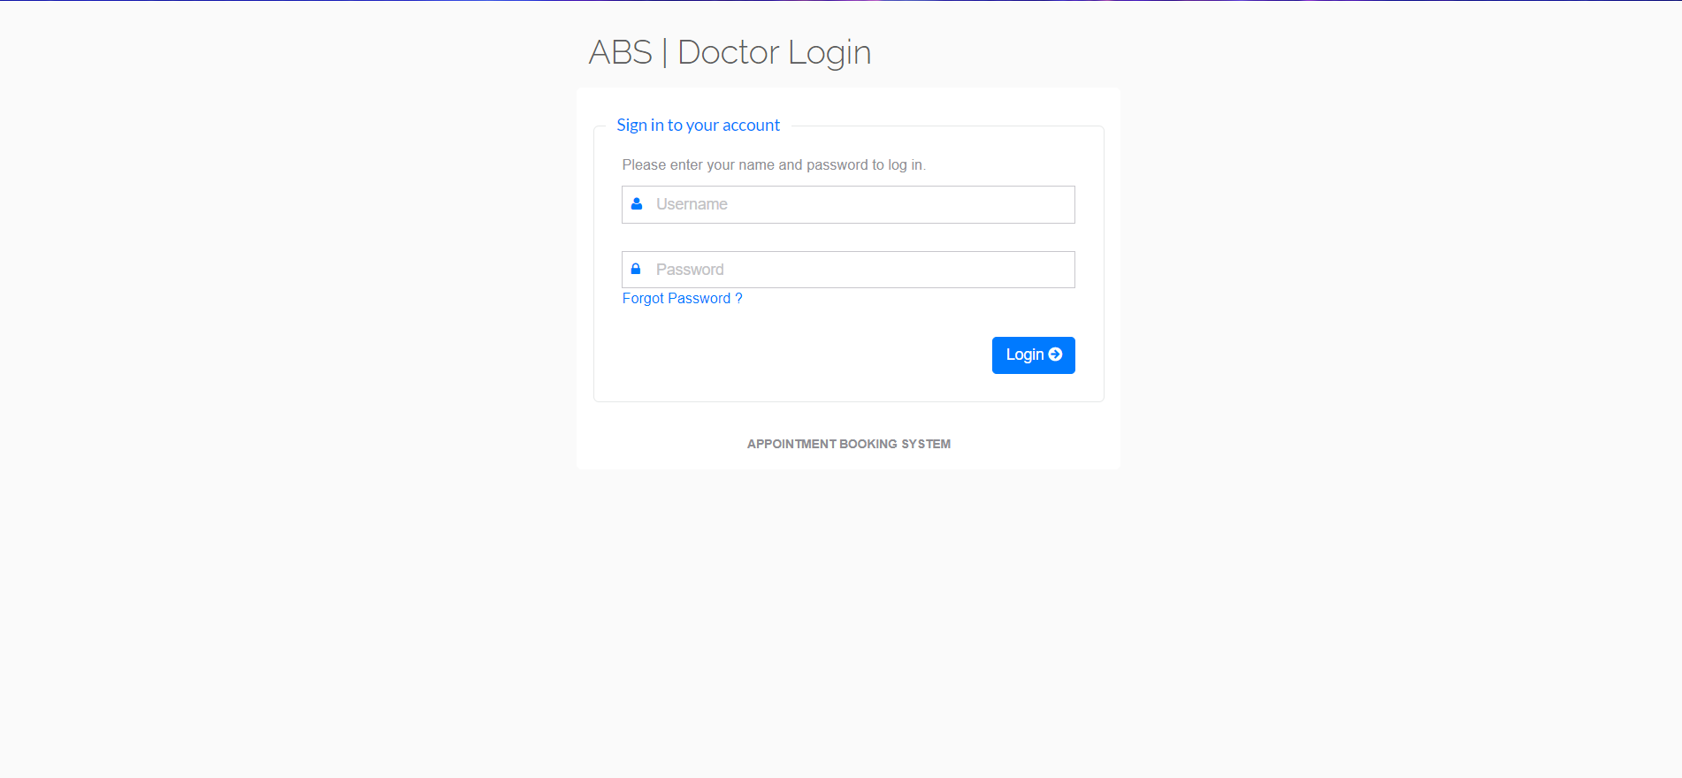

**Figure: 5**

#### Doctor's Dashboard :

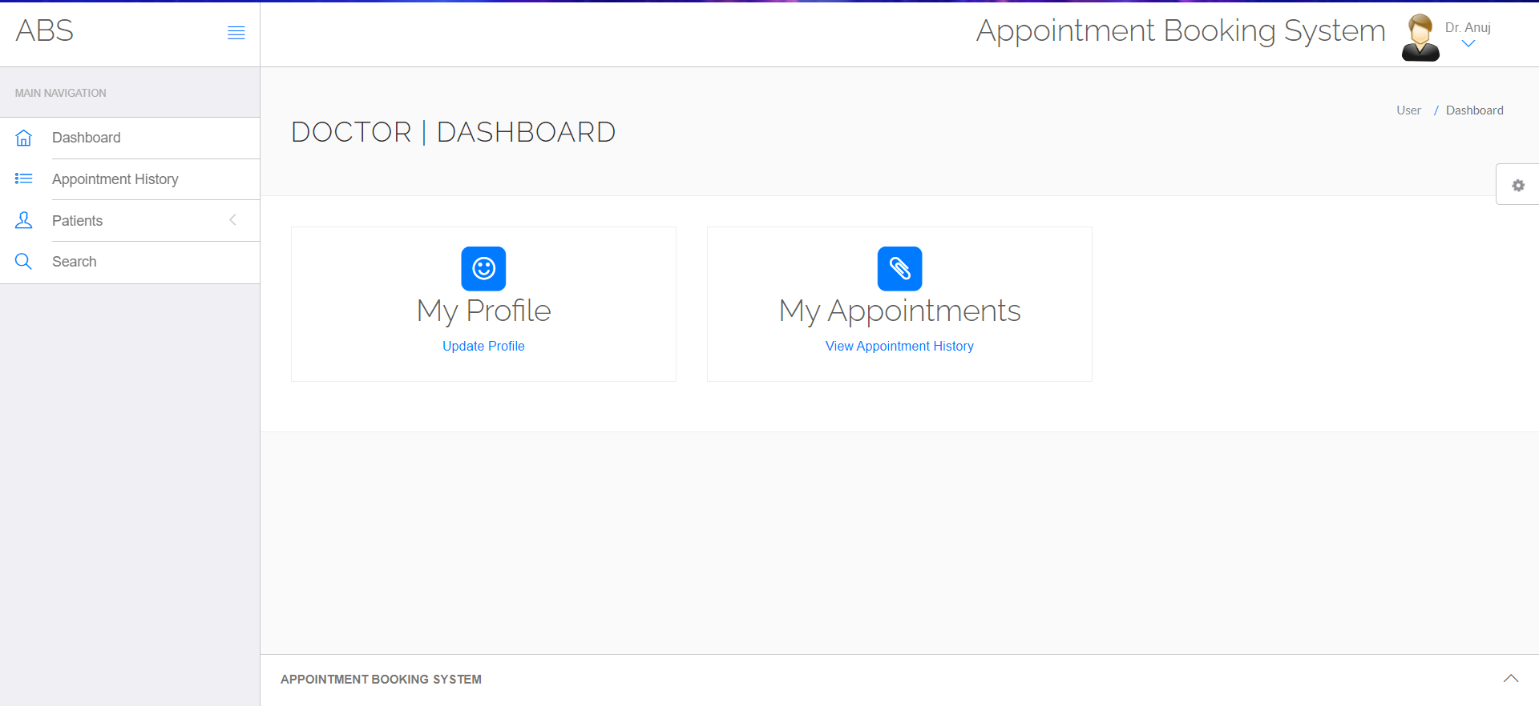

**Figure: 6**

#### Management / Admin’s Login :

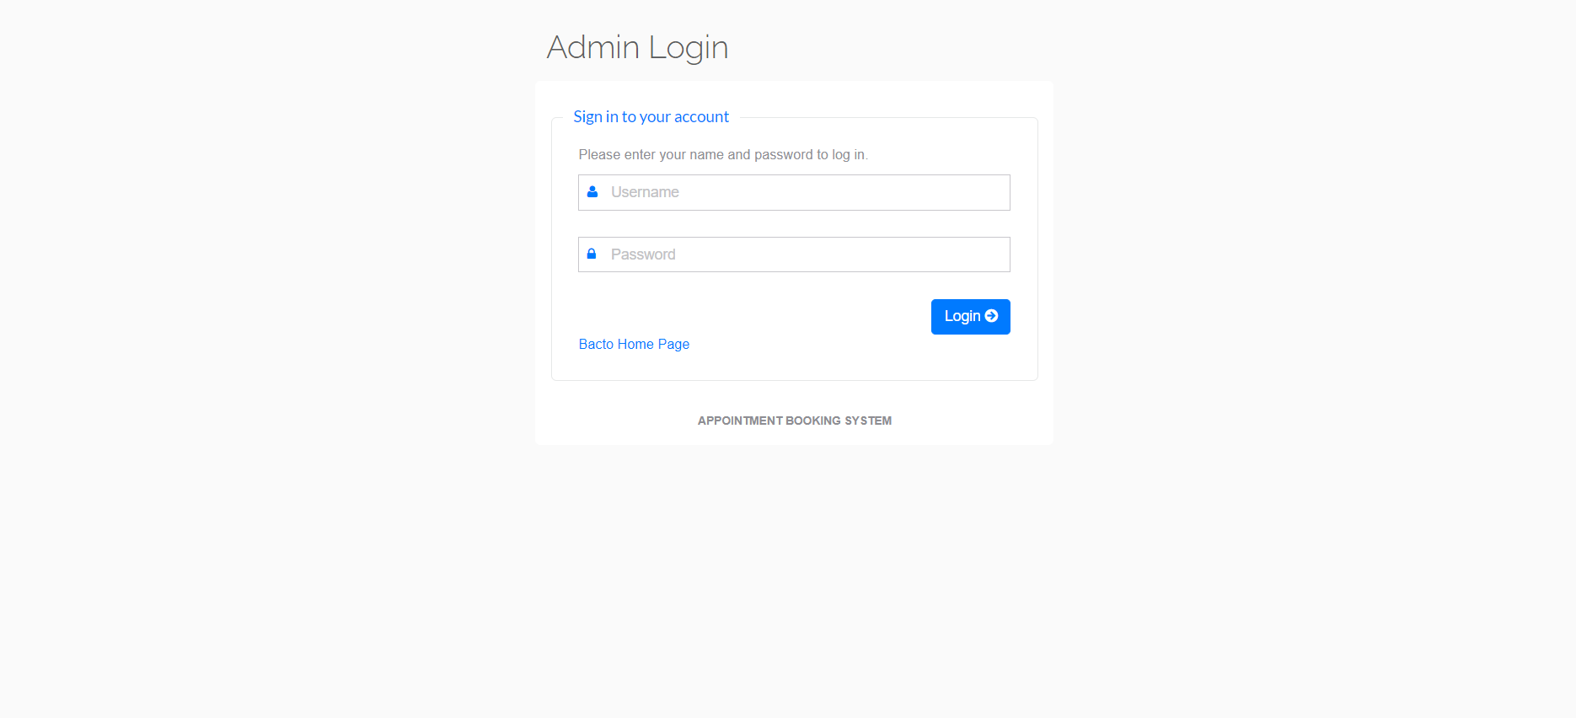

**Figure: 7**

#### Management / Admin's Dashboard :

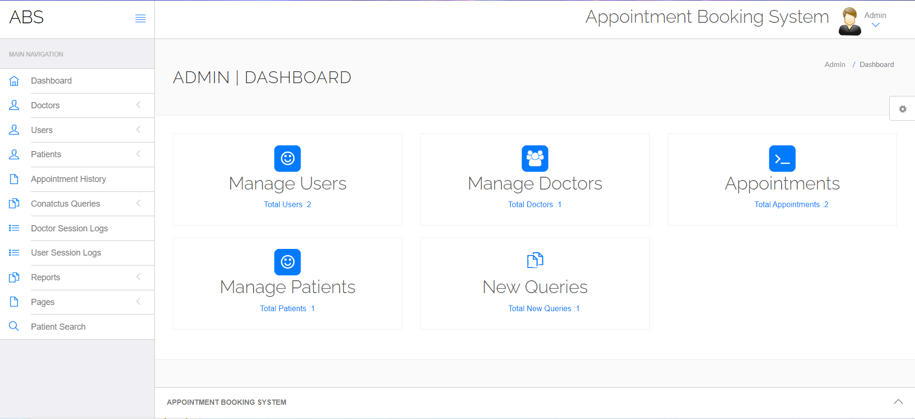

**Figure: 8**

**3.5 Some Snapshots of Database Interface**

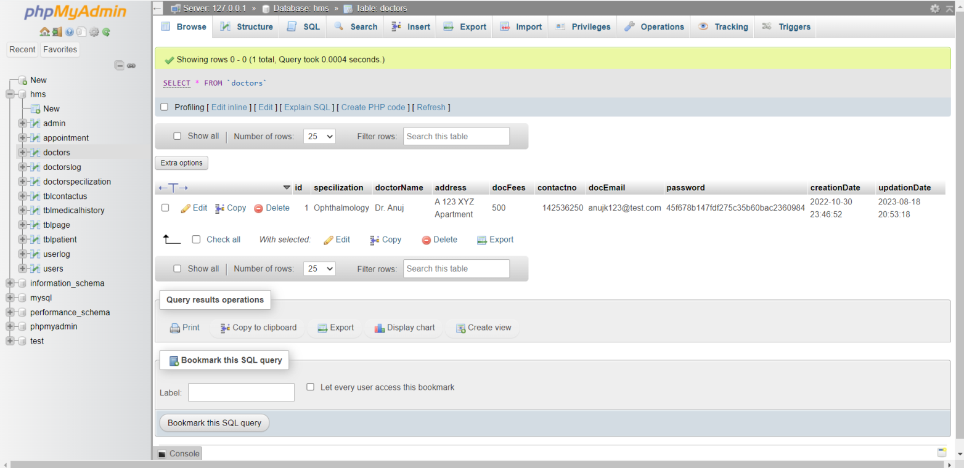

**Figure : 9**

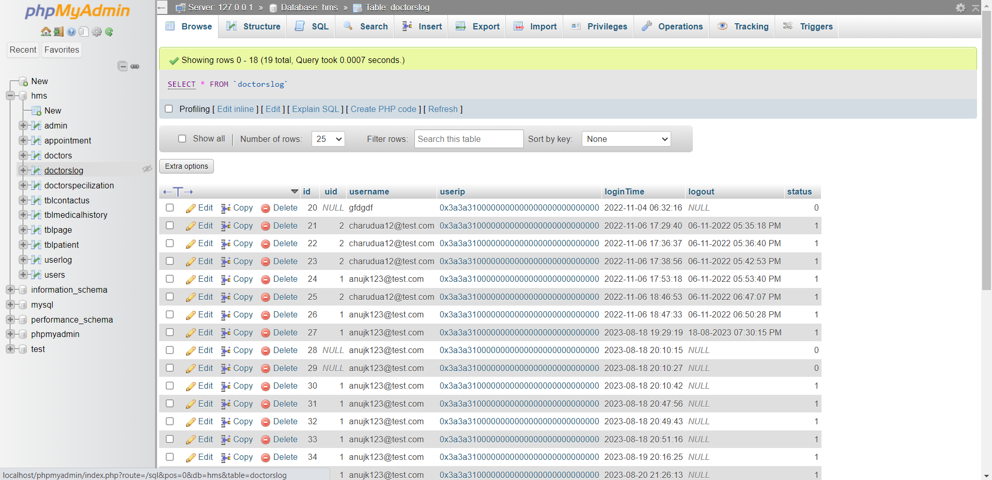

**Figure : 10**

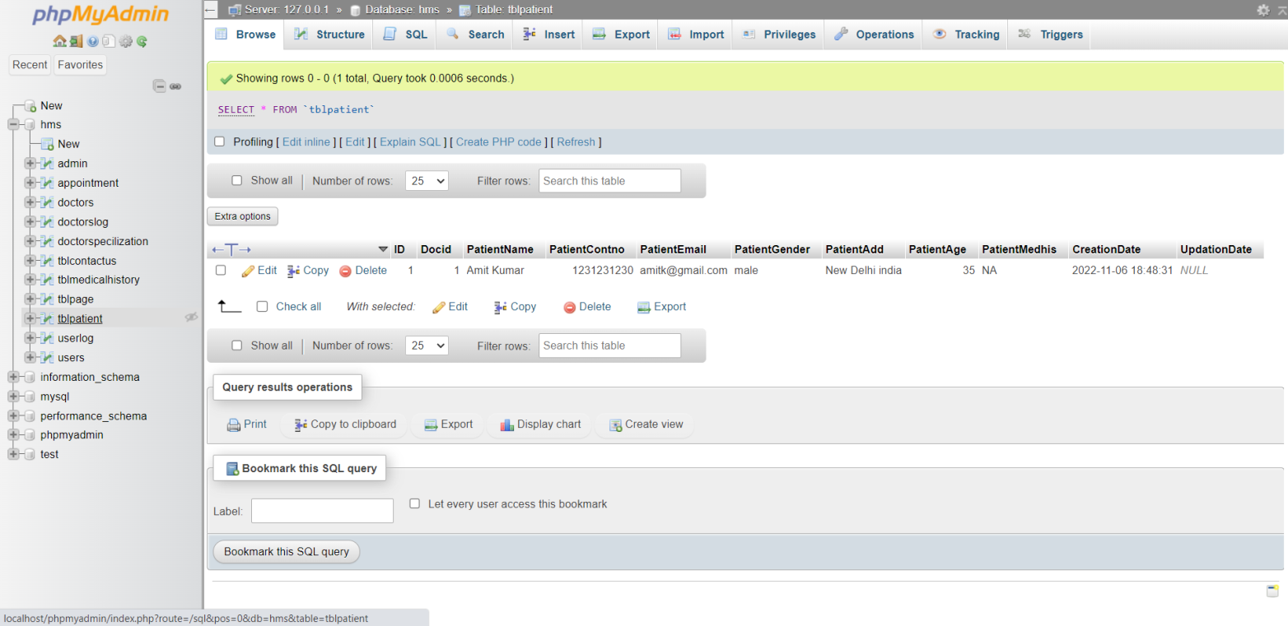**Figure : 11**

# Chapter 4 : Conclusion and Future Work

**4.1 Conclusion**

The concluding chapter highlights the achievements and benefits of the Appointment Booking System project. It emphasizes the significance of digital solutions in enhancing healthcare administration.

This comprehensive project report outlines the Appointment Booking System's structure, functionalities, and implementation details, showcasing its potential to revolutionize healthcare resource management and patient care.

Appointment Booking System websites contribute significantly to improving the efficiency, quality, and accessibility of healthcare services. By effectively managing resources, enhancing patient care, and leveraging data- driven insights, these platforms play a vital role in shaping the future of healthcare delivery and administration.

#### 4.2 Future Work

This section outlines potential areas for future improvement. Suggestions might include integrating telemedicine capabilities, enhancing reporting features, and expanding user roles and permissions.

The future of Appointment Booking Systems will likely involve advancements in technology, data analytics, and patient-centered care. The future of Appointment Booking Systems will revolve around harnessing technology, data, and collaboration to provide efficient, patient- centered care while navigating the complexities of modern healthcare environments.

# References

* 1. PHP MySQL Website Programming: Problem - Design – Solution by Chris Lea, Mike Buzzard, Dilip Thomas , Jessey White-Cinis
  2. Beginning PHP5, Apache, and MySQL Web Development (Programmer to Programmer) by Elizabeth Naramore
  3. MySQL/PHP Database Applications, 2nd Edition by Brad Bulger
  4. How to Do Everything with PHP and MySQL by Vikram Vaswani
  5. Jon Duckett's HTML and CSS
  6. A beginner's guide to HTML, CSS, Javascript, and Web Graphics, by Jennifer Niederst Robbins
  7. Marijn Haverbake's Eloquent Javascript
  8. Kyle Simpson's You Don't Know JS
  9. Don't Make Me Think by Steve KrugFullstack Vue: The Complete Guide to Vue.js by Hassan Djirdeh, Nate Murray, and Ari Lerner
  10. PHP and MySQL for Dynamic Web Sites: Visual QuickPro Guide by Larry Ullman
  11. Don't Make Me Think, Revisited: A Common Sense Approach to Web Usability by Steve Krug